Name: _____________________________ Period: ________ Date: ______________

Background Learning Stations:
The Miracle Worker by William Gibson
Station One: Trust Walk

Trust Walk Reflection
If you were the blindfolded partner, answer these questions: | If you were the guide partner, answer these questions:
-What was your task to perform during the trust walk? Did you complete it successfully?  -Describe how it felt to be “blind” during the trust walk.  -Did your partner have to help you a lot?  -How did your sense of hearing help you to complete your job?  -How did your sense of touch help you to complete your job?  -What was the most significant moment for you during the trust walk? | -What was your partner’s task during the trust walk? Did they complete it successfully?  -Did you have to help your partner a lot? Describe the help you gave them.  -Do you think it was more difficult to be the blindfolded partner or the guide partner? Why?  -Did your partner use their sense of hearing or sense of touch more often? Why?  -What was the most significant moment for you during the trust walk?
Station Two: Ivy Green
http://www.helenkellerbirthplace.org/
- Where is Ivy Green located?

- Who originally built the home?

- Who lived in the small cottage?

- How did Ivy Green get its name?

- What play is performed here?

- Take the virtual tour of the grounds. What interests you about Ivy Green? Is it a place you'd like to visit?

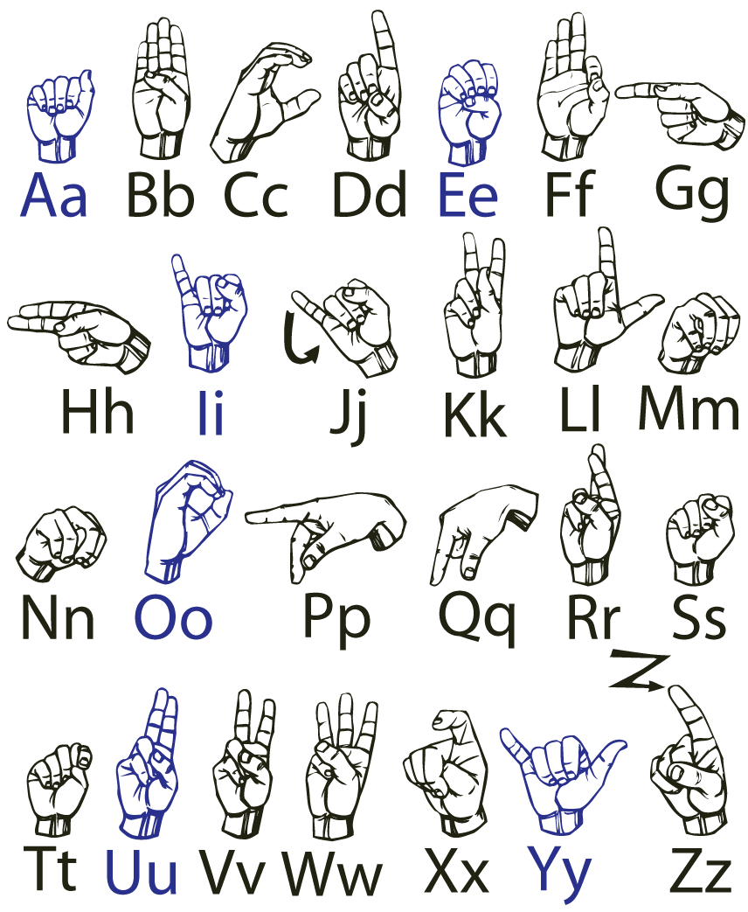
Station Three: American Sign Language Fingerspelling

- With your partner, practice the ASL alphabet.
- Then spell the following words with your partner slowly.

bug cat ball

3) Spell three new words to your partner. Record the words that your partner fingerspells to you.

________ __________ ________

4) Try spelling a word into your partner’s hand. They should focus on feeling the shape of your hand, rather than looking at the letter.

Station Four: Scene from the movie https://www.youtube.com/watch?v=lUV65sV8nu0

With your group of four, watch the scene from the original “Miracle Worker” movie. You can stop the video at 3:30 so you have enough time to answer the questions. Answer the questions listed on your sheet and then discuss.

-What was Helen doing when she realized that w-a-t-e-r meant water?

-How do you think she felt at that moment?

-Why was Helen so frantic after learning that first word?

-Why did Helen feel Annie’s face after spelling a word?

-How do you think Helen’s parents felt when she could finally spell m-o-t-h-e-r and f-a-t-h-e-r?

Station Five: William Gibson’s NPR Interview https://www.npr.org/templates/story/story.php?storyId=3843114

- Before writing The Miracle Worker, had Gibson ever written for TV?

- How long did it take him to write The Miracle Worker?

- What made The Miracle Worker so successful as a teleplay, play, and a movie is that Gibson made __________________ the main character, not Helen.

- Gibson believes the secret to the success of his play is Annie and Helen’s ________________ against a world they don’t understand.

- What year did Annie Sullivan die? ___________

Station Six: “The Story of My Life” by Helen Keller

Read the excerpt from Helen Keller’s autobiography and answer the multiple choice questions.

1.
2.
3.
4.
5.
6.
7.
8.
9.
10.

