Name________________________________________ Period___________ Date_______
Directions: Read the following passage and annotated key points and make comment in the margin about how the different points relate to each other and what inference one can make from the article. Underline or circle or cross out material, which ever method works best for you. Make sure you have marked at least nine areas. Put the number of the question that the material will help you answer.
The passage below is followed by questions based on its content. Answer the questions on the basis of what is stated or implied in the passage.

If you are lucky enough to see wolf tracks in the wild, you will probably not see the footprints of just one single animal. Wolves travel in groups; they hunt in groups, and they perform almost all the other activities of their lives in the company of fellow wolves. This is one of the most important facts that modern science has learned about wolves and one of the things that most clearly explains their way of life.
The pack, the basic unit of wolf social life, is usually a family group. It is made up of animals related to each other by blood and family ties of affection and mutual aid. The core of a pack is a mated pair of wolves—an adult male and female that have bred and produced young. The other members of the pack are their offspring: young wolves ranging in age from pups to two-and three-year-olds. Most packs have six or seven members, although some may include as many as fifteen wolves.
Relationships among creatures that live close together in groups are often very complicated, and this is true of the ties that connect the members of a wolf pack. Scientific studies of captive wolves and wolf packs in the wild have shown that many complex rules of behavior seem to govern the way that the animals relate to each other. The methods that wolves use to communicate with fellow pack members are also elaborate.
When wolf pups are born into a pack, one of the most important things they must learn is the “language” of the group, the method by which pack members keep in touch with each other, sharing information and communicating their feelings. Scientists have discovered that wolves have a very complicated system of communication, quite different from the language of humans but used in a similar way to convey meaning.
The most famous wolf sound is, of course, the howl, and it is a very important part of wolf language.
When people think about howling, they usually imagine a mournful, lonely sound made by a wolf sitting all alone on a hilltop in the moonlight. Like most human images of wolves, however, this one is not very accurate. Wolves howl at any time, not just at night, and they often howl together, not alone.
Group or chorus howling is another means by which the members of a wolf pack reaffirm their ties with each other and their closeness as a group. One wolf—often the alpha male—will point its nose at the sky, open its mouth, and start to howl. Immediately, the other members of the pack rush to stand beside him, shoulder to shoulder, and join their voices to his. The whole group seems to be excited and happy, tails wagging and bodies wiggling. Each wolf howls on its own note so that a grand chorus of slightly different sounds is produced.
Chorus howling often takes place before a wolf pack goes out to hunt. This ceremony of togetherness may encourage the pack members to cooperate with each other in the difficult job of finding and bringing down prey. At the end of a successful hunt, the pack may also celebrate with a group howl. While wolves track prey, they are usually silent.
There are occasions when a wolf will howl by itself. This may happen when an animal is separated from the pack and is trying to locate its companions. Pack members seem to recognize each other’s voices and will keep responding to the howl of their wandering relative until the group is reunited.
Because howling is a sound that carries over a considerable distance, it is very useful in communications among separated members of a pack. Howling is also used when members of different packs have to get in touch with each other to relay information about their locations and their intentions.

1. According to the selection, what aspect of wolves’ lives makes communication most important for them?

- Wolves live in packs.
- Wolves hunt at night.
- Wolves occupy a large territory.
- Wolves are an endangered species.

2. What most likely happens to young wolves after the age of four?

- They leave the pack and live alone.
- They leave the pack to form packs of their own.
- They continue to live as part of their original family pack.
- They take over from their parents to become leaders of their pack.

3. Which of the following phrases belongs in the empty circle below?

- While tracking prey
- When separated from the pack
- Because it is night
- Because it is daylight

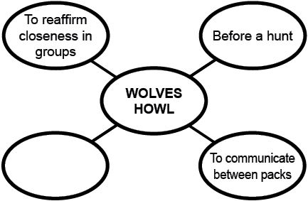

4. Most wolf packs consist of how many members?

    - 3-4
    - 4-5
    - 6-7
    - 9-10

5. To what human activity could wolves’ “chorus howling” best be compared?

- A baby crying from hunger
- A choir putting on a concert
- A family having an argument
- A sports team cheering before a game

